Normal-Case 2 (1 RSU + 10 Cars):

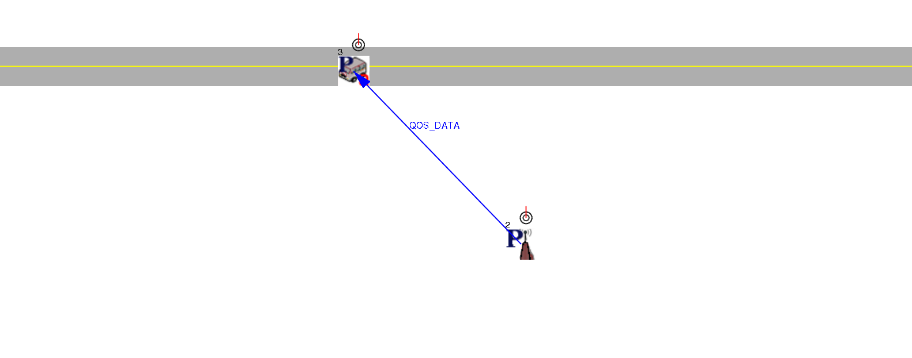

Normal-Case 3 (1 RSU + 20 Cars):

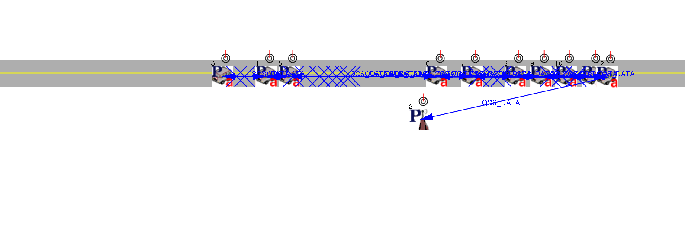

Normal-Case 4 (1 RSU + 40 Cars):

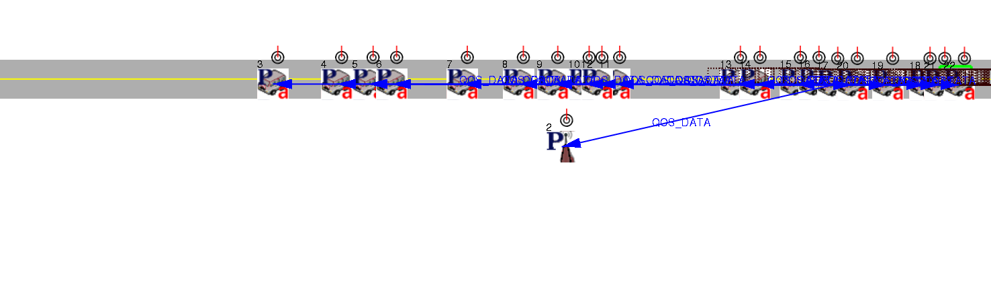

Normal-Case 5 (1 RSU + 60 Cars):

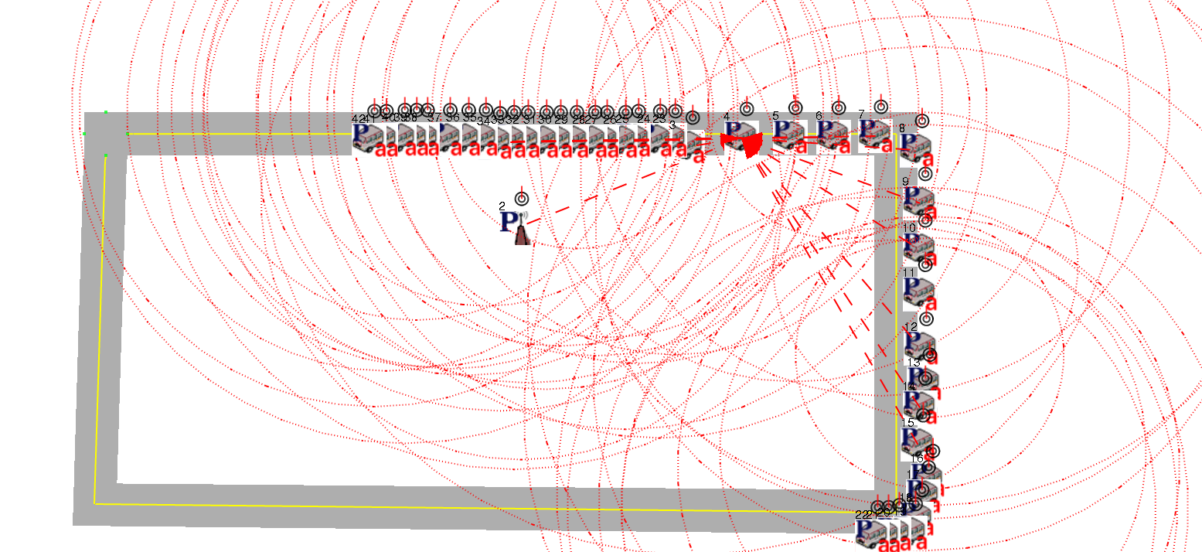

Normal-Case 6 (1 RSU + 80 Cars):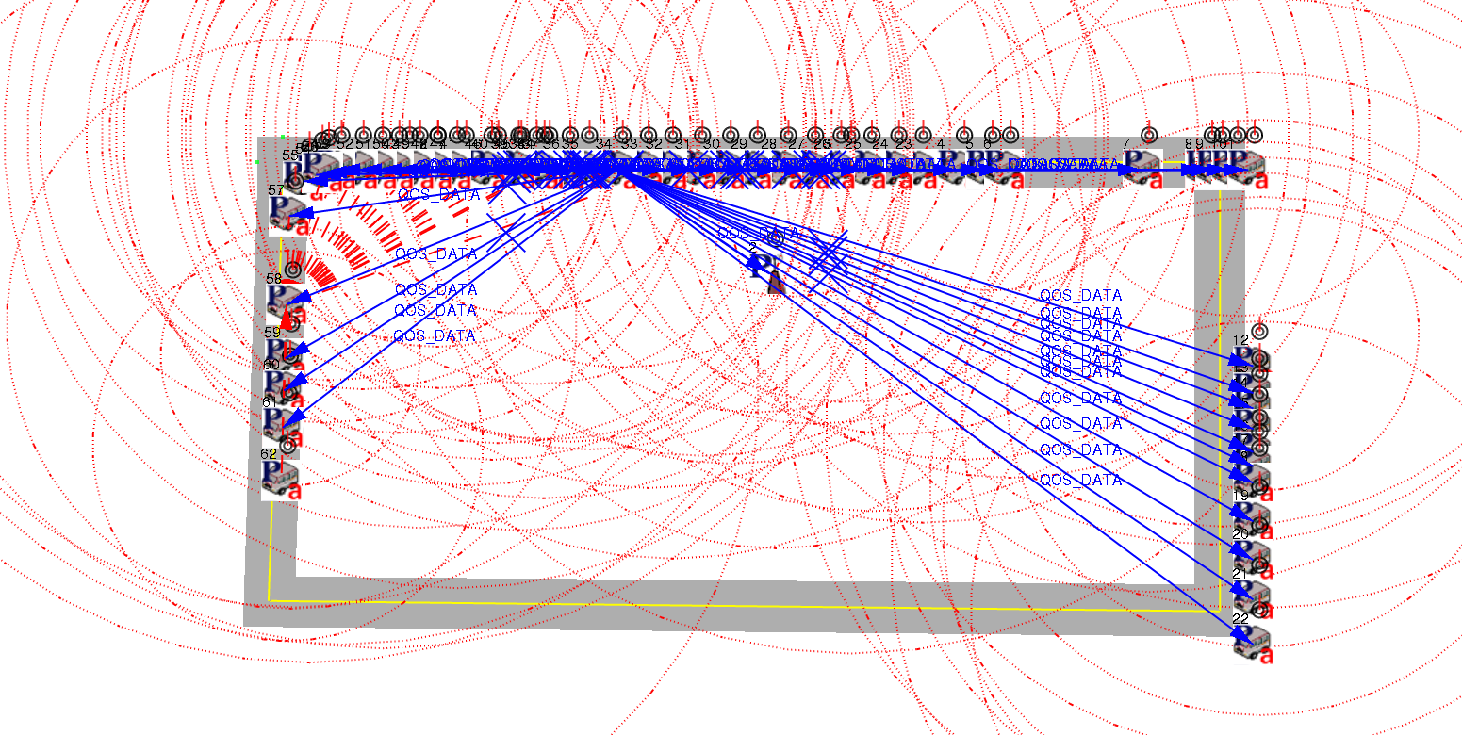

Normal-Case 7 (1 RSU + 100 Cars):

